**Technical Proposal Towards Contact Center Solution**

**for**



**RFP Ref: EDGE-RFP-61-2023**

**Proposal Ref: COG-EDGE-CC-202308001**

**Date: 3rd August 2023**

***Confidentiality Statement***

*This proposal is being submitted to EDGE/EBS “Client” by Cognicx “Partner” in response to the site inspection and audits requirements as shared, that the Contents of this document will not be divulged to any third party without the express written consent of Cognicx. Also, the Partners will not divulge any of the clients or its customer’s confidential information that is attained during the course of the execution of this project It is also understood that Partner will not divulge any of client or its customer’s confidential information that it may have access to in the course of executing the project described in this proposal.*

Table of Contents

**Executive Summary** 4

**Our Understanding of the Business Requirements** 7

**Proposed Solution & Technical Approach** 8

**Detailed Scope of Work** 22

**High Level Deployment Timelines** 26

**Governance Model** 27

**Key points to note and Dependencies** 27

**ANNEXURE A: SUPPORT SERVICES** 28

**ANNEXURE B: CISCO BOQ for 15 Agents** 31

**ANNEXURE C: COMPLETED PARTC-BIDDER RESPONSE DOCUMENT** 33

**ANNEXURE D: TEAM COMPOSITIONS AND ASSOCIATES CV’s** 35

**ANNEXURE E: COMPLIANCE TO SOW** 44

**ANNEXURE F: BIDDER’S EXPERIENCE** 47

|  |  |  |  |
| --- | --- | --- | --- |
| CHANGE LOG | | | |
| **DATE** | **VERSION** | **AUTHOR** | **CHANGE DESCRIPTION** |
| 3rd August 2023 | 1.0 | Rohit Raole | Technical RFP Response Document |

|  |  |  |
| --- | --- | --- |
| COGNICX CONTACT DETAILS | | |
| **NAME** | **PHONE** | **EMAIL** |
| Rohit Raole | +971 50 7070253 | [rohit.raole@cognicx.com](mailto:rohit.raole@cognicx.com) |

# **Executive Summary**

In today’s continuously evolving fast paced Digital world, Connected & Collaborative experience are the key drivers for having engaged customers. Providing exceptional and differentiated customer service offering to the customers becomes the key aspect of any business engagement.

EDGE is one of the world’s leading advanced technology groups, established to develop innovative solutions for defence and beyond, and to be a catalyst for change and transformation. Edge Group is dedicated to bringing breakthrough innovations, products, and services to market with greater speed and efficiency, positioning the UAE as a leading global hub for future industries, and creating clear paths within the sector for the next generation of highly-skilled talent to thrive. Headquartered in Abu Dhabi, the capital of the UAE, EDGE is an advanced technology group which consolidates more than 20 entities into four core clusters: Platforms & Systems, Missiles & Weapons, Electronic Warfare & Cyber Technologies, and Trading & Mission Support.

EDGE wants to enhance the customer experience by providing helpdesk services to their internal users for IT-related queries/issues they may have. EDGE has released RFP to provide Call Center Solution for EDGE/EBS and integrate the call center with the Manage engine and Secret Double Octopus (SDO). Cognicx is delighted to align with EDGE’s initiative and provide the proposal for the implementation along with associated licenses, Product and Application Support services engagement that covers:

* Supply of licenses, Deployment and configuration of Cisco UCCX contact centre platform
* Self-Service IVR (DTMF based in English, Arabic),
* Integration with Manage engine and Secret Double Octopus (SDO)
* Cisco voice channel configurations and integration with
* Call back and Customer feedback on IVR,
* Contact centre KPI reporting dashboard and Real-time wallboard for Voice.

This RFP response covers the proposed solution, which is designed to meet the robust deployment requirements of EDGE. Cognicx is excited about the opportunity of becoming the preferred partner for EDGE. Cognicx looks forward to working with your team to deliver an outstanding solution that will bring great success to EDGE, both in the near term and the long term. The subsequent sections detail the scope covered.

**About Cognicx:**

Cognicx IT Solutions intends to reach out to its customers and touch their lives one way or another, which is why the Cognitive interface is based on several noteworthy human-like decision-making abilities that help them to get more closer to their customers by being empathetic and yet personalized. The world is looking for such solutions, and by infusing the cognitive touch, we Cognicx IT Solutions deliver it to you.

Cognicx, a rapidly growing organization focusing on Cognitive Customer experience through Secure and integrated Digital transformation across various industries. Cognicx can help businesses fully realize the potential of technology by helping them maximize the value of their deliverables. With its niche combination of best-in-class Consulting, Partners, and technology, Cognicx enables its customers to operate more efficiently and successfully in the markets they serve.

Being at the forefront of next-gen digital technologies, we provide customer engagement solutions by leveraging the cognitive interfaces that take the company’s capabilities to the next level.

We work in close cooperation with you to plan, develop, and design the solutions to differentiate your offerings to your customers.

PARTIAL LIST OF BRANDS WE ARE WORKING WITH:

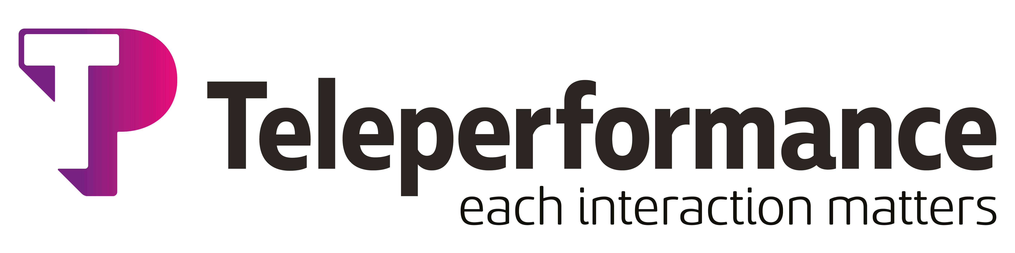

VENDORS & PARTNERS:

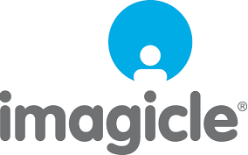



**The further details about Cognicx are provided in the Annexure: Company background:**

**About Cisco:**

Cisco is THE WORLDWIDE LEADER, their solutions connect people, computing devices and computer networks, allowing people to access or transfer information without regard to differences in time, place, or type of computer system. The company was founded in 1984 in San Francisco, now a multi-national corporation, with over 35,000 employees in more than 115 countries. Today, Cisco solutions are the foundations for service providers, small to medium business and enterprise customers which include corporations, government agencies, utilities, and educational institutions.

Cisco is recognized as a leader in the Gartner Magic Quadrant for the Contact Center Domain. Cisco lays great importance in their R&D and is always leading the pack in terms of innovation and efficiency that gets passed on to your organization. Take a case of having a true connected and integrated experience across your enterprise ONLY cisco platform the essential building block be it a unified communication to the collaboration suite, that runs on a single platform, this gives your enterprises the leading edge of embracing a “True Connected & Integrated Experience”.

Cisco solutions helps your business to:

* Engage with your customers and prospects whenever and however they prefer.
* Provide personalized service through every step of the customer journey.
* Make customer service agents more efficient, productive, and motivated.
* Track the context of previous customer interactions, allowing your customer service agents to provide better/faster customer service.
* Better understand and improve your customer engagements through reports and analytics.
* Identify up- and cross-sell opportunities to increase profits even while decreasing contact center costs.

**Our Understanding of the Business Requirements**

EDGE/EBS is looking for setting up a voice-based contact center for their helpdesk. EDGE/EBS wishes to start with basic setup and enhance the functionalities as they stabilize the helpdesk operations.

Below is the high-level scope requirements basis the RFP as released by EDGE procurement team:

**SCOPE FOR CONTACT CENTER SOLUTION**

1. Supply, installation of the voice channel cisco contact center platform for 15 agents and 1 supervisor in High Availability (HA).
2. IVR self Service: The IVR functionalities (up to 8 menus) to include the functionalities for e.g.
   * Existing case status, open a new case, reopen case, Call to personal emergency number, Voicemail etc.
   * Preferred and differential treatment to the VVIP, VIP callers.
3. Call recording for caller agent interaction over voice & deployment of Quality monitoring solution for the contact center.
4. Dashboard for the key KPI’s from contact center and manage engine.
5. CTI Screen POP up of the incoming caller.
6. Call back option to be provided to the callers
7. Call survey to collect feedback from the callers on the IVR and support the integration with manage engine.
8. Integration with ManageEngine to get the ticket related information and caller information.
9. Self service automation for the users to carry out the password reset by authenticating it using Secret Double Octopus.

# **Proposed Solution & Technical Approach**



EDGE wishes to elevate the customer experience by implementing a dedicated contact center platform powered by Cisco as a part of their project. Further to the business requirements as shared through the RFP as released by EDGE procurement team, Cognicx proposes the following:

1. Contact center platform: Cisco UCCX with 15 agent licenses
2. DTMF based IVR call flow development and integrations.
3. Integrating self-service IVR with Manage Engine and Secret double Octopus. The integration would be through API’s.
4. Call Survey module for clients to provide their feedback on the IVR.
5. Call back management module for callers waiting above a threshold time in the queue those need to be called back.
6. Configuration of voice channel on the Cisco UCCX platform.
7. Reporting and analytics powered by Cisco CUIC reporting.
8. Real-time dashboard and wallboard for displaying on the LED screens the contact center KPI’s for voice and non-voice channels as pulled from Manage Engine.
9. Deployment of Quality monitoring solution for the contact center.

**OUT OF SCOPE FOR COGNICX:**

The development and integration of non-voice channels namely Webchat, Chat Bot, email, social media, WhatsApp, SMS and any associated integration of these channels with Manage engine or Secret Double Octopus is not considered in this scope of work under this proposal.

**SOLUTION DESCRIPTION**

**Cisco UCCX Contact Center Platform:**

The Cisco® Unified Contact Center Express (CCX) product line helps businesses and organizations deliver a connected digital experience, enabling you to provide contextual, continuous, and capability-rich journeys for your customers, across time and channels. This easy-to-deploy and easy-to-use solution supports up to 400 agents and is designed for midmarket companies or enterprise branch offices. Secure and highly available, it supports powerful agent-based services and fully integrated self- service applications, including Automatic Call Distributor (ACD), Interactive Voice Response (IVR), Computer Telephony Integration (CTI), and digital channels including email and chat.

Key Features:

Cisco Unified CCX helps deliver each of your contacts to the right agent the first time. It enables this accuracy with sophisticated business rules for inbound and outbound voice, email, web chat, and customer interaction management. Cisco Unified CCX also offers numerous agent and desktop services and can scale to larger, more demanding environments.

The Cisco® Business Edition 6000 (BE6000) gives employees a full range of collaboration tools: premium voice, video, messaging, instant messaging and presence, conferencing, video conferencing, contact center services, mobility capabilities, and more. With these tools your small or midsize business can boost productivity among employees and strengthen relationships with customers and business partners. And they can help you speed decision making and reduce time to market.

**Solution Components Details**

**CISCO Gear:**

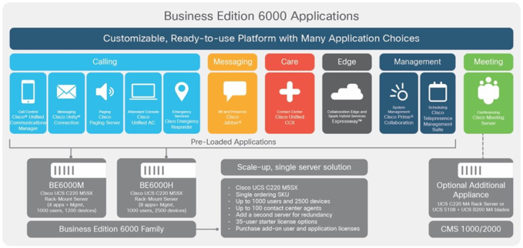

**Unified Communications Manager (UCM)**

Cisco Unified CM is the call-processing engine of Cisco’s Collaboration Architecture.

* It extends voice and video features to network devices such as IP phones, telepresence endpoints, media-processing devices, gateways, and multimedia applications.
* It is equipped with instant messaging and presence services, and multimedia conferencing, collaborative contact centers, and interactive multimedia response systems are made possible through Cisco Unified CM open telephony APIs.

**Unified Contact Center Express (UCCX)**

Cisco Unified CCX is the main ACD brain for the Contact Center.

* Cisco Unified Contact Center Express provides a secure, highly available, and easy to deploy customer interaction management solution.
* Unified CCX provides options to address multiple contact center functional areas such as:
  + - Inbound voice
    - Outbound campaign
    - Conditional Routing: Unified CCX supports routing based on caller input to menus, real-time queue statistics, time of day, day of week, ANI, dialed number, and processing of data from XML text files.

**Agent Desktop (Cisco Finesse)**

* + - Browser-based agent desktop for easy management & upgrades
    - Designed to empower agents via user-centered design product
    - Flexible and Expandable – Finesse is a web gadget container
    - All applications that agents need (Cisco or 3rd party) contained within Finesse
    - Administrators define agent and supervisor layouts
    - Developer Friendly Web API

**Self Service IVR Application (DTMF Based)**

The solution will be developed on the Cisco platform with the focus on accessibility, Quality Assurance, responsiveness, and feedback. The IVR application provides comprehensive list of self-service functionalities to the user and helps the caller to inquire/transact/complain using the application.

**Self Service IVR Overview**

* The IVR application will be developed and deployed using Cisco IVR Platform
* The IVR self-service applications will support the following languages:  English and Arabic
* The call flow for both languages would be exactly the same.
* The IVR application will be DTMF based.
* There will be call back and call survey options available on the IVR.
* The IVR application will be integrated with the Manage engine and SDO using restful API’s.
* As the IVR can collect 0-9 digits so the client identification number is required a Numeric only.

We will be developing the IVR self-service application in line with the services as listed below.

| **Sr. No** | **Features** | **Description** |
| --- | --- | --- |
| **1** | Welcome Message | * IVR application plays the welcome message |
| **2** | Language Selection | * IVR application provides the caller with the two language options – Arabic and English. * Caller can choose their language |
| **3** | Main Menu | IVR application will provide the caller with the main menu options:   1. Existing Case 2. Open A Case 3. Re-open Case   Note: for 1st and 3rd Option collect case id from customer and open the ManageEngine URLs in Finesse -if iframe supported it will be within Finesse Gadget, otherwise browser pop will be configured |
| **4** | Sub menu with integration with Manage Engine and SDO | Upon the main menu selection, the following sub menus will be played to the caller and after the sub menu selection, at this stage the integration with Manage engine will happen within IVR wherein the output detail from manage engine will be played back to the caller.  Note: Open New case will spawn into 3 level menus, [New 8 menus will be Introduced]  Manage Engine Interaction with in IVR will be to   * Identify the Customer * Get Existing case status * Register New case * Re-open Existing case |
| **5** | Non-Working hours Functionality | During non-working hours following 3 options will be given.   * Call to personal emergency number * Voicemail * Call back option |
| **6** | Transfer to agent | * In case the user is unable to get serviced on the IVR application, the IVR will transfer the call to the available agents. |

As the IVR can collect 0-9 digits so the client identification number is required a Numeric only

Here is call flow attached for the Self service



**Call Back Option:**

If any caller waiting in the Queue the System will collect the call back request from the caller and present it as a preview campaign to the outbound agents.

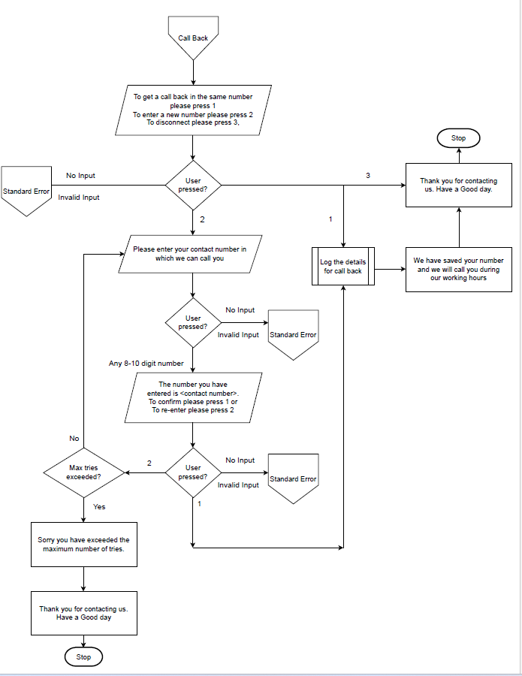

**Post Call Survey Application:**

At the end of every inbound call, if the customer is willing to provide feedback / survey, then the agents would transfer the call to the survey IVR application. The Call survey application will be in English and Arabic with the below features:

* The application would announce a max. of 5 questions to callers.
* The answers would be either Yes/No or Ratings (1-5) based.
* The application would accept DTMF inputs only.
* The questions and their corresponding responses will be read from a configuration file.

**Call Survey, feedback, customer happiness: Inbound Process flow**

1. Caller calls the contact center.
2. IVR prompts the caller for language selection.
3. Caller is provided with main menu options based on the language chosen.
4. Caller navigates various menus from level 1 to level 5 in the IVR.
5. Upon completing the menu traversal in IVR, caller is prompted in IVR, whether caller is willing to participate in the call survey.
6. If caller accepts to take part in the survey, the IVR application will log the information in the database.
7. The survey application will provide list of options to the caller to measure satisfaction level.
8. Caller will provide input in Survey Application, for example the caller is conveyed to choose the response from scale of 1-5.
9. This survey responses data will be updated in database for reporting purpose.

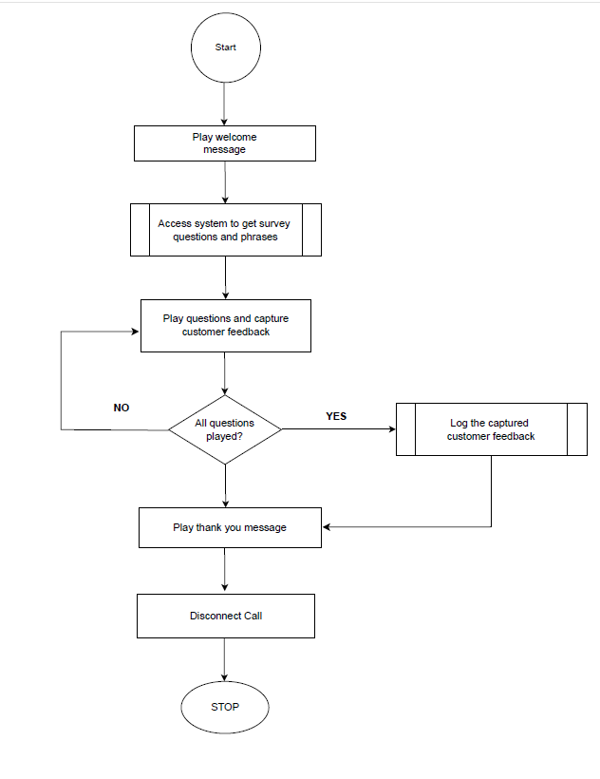

**Call Survey Admin:**

Survey admin module will help the customer to add / Edit / Delete the Survey question dynamically for the selected survey module.

**Maintain Survey Templates:**

**In this screen the system admin will be able to:**

* Create the survey template – In this screen the system admin will combine questions to be played in IVR, the minimum, maximum score, phrase file names can be configured.

**Template configuration:**

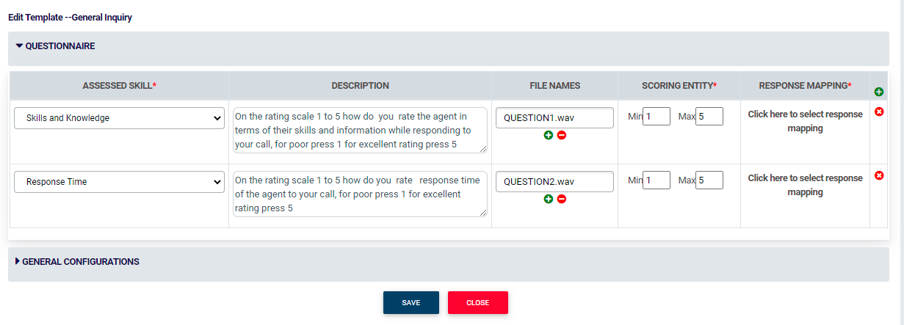

**Note:**

For each survey maximum of 5 questions can be configured.

**Response Mapping:** The Mapping for Each Key Press can also be defined as follows

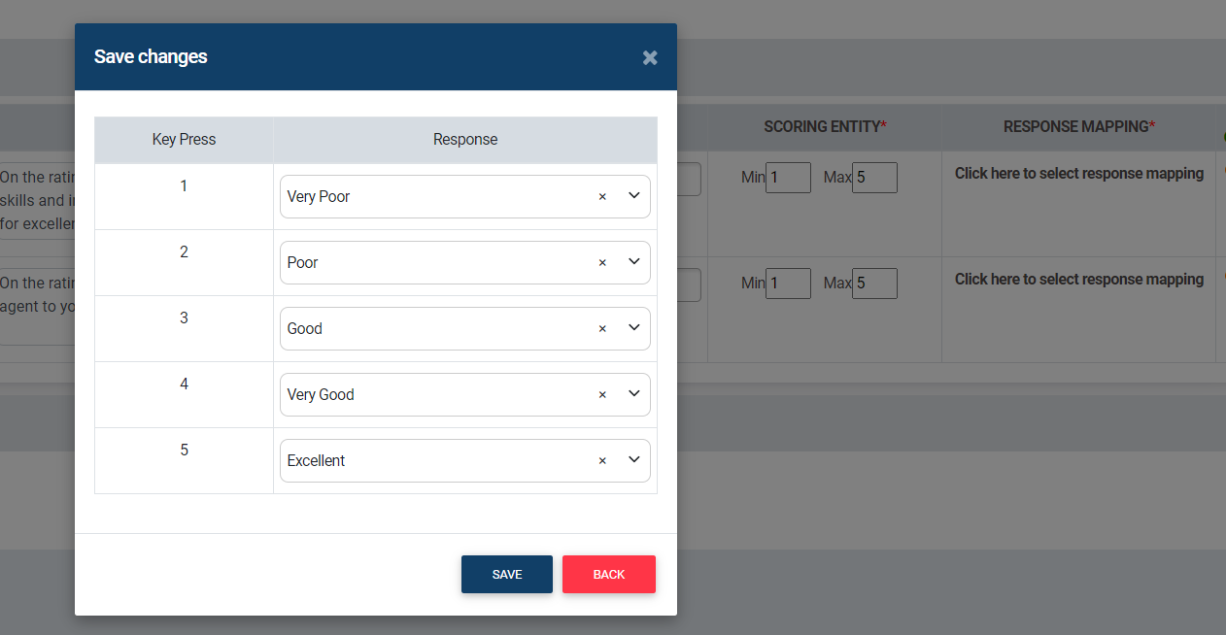

**General configurations for Survey:** The General IVR configurations like maximum tries, number of Tries, welcome message to be played in Survey IVR etc., can be configured through this page.

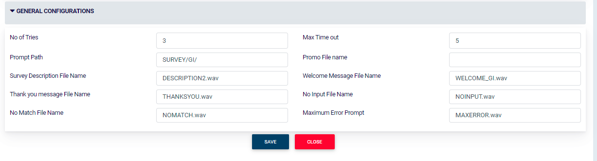

**View Mapped Survey Template:**  The configured survey template can be viewed as follows

Definition for Each DTMF input will be mapped in this page for each question

For each question Minimum and maximum DTMF Key press can be configured. Example 1 to 5, 1 to 9

Note [minimum DTMF – 0 and Maximum – 9]

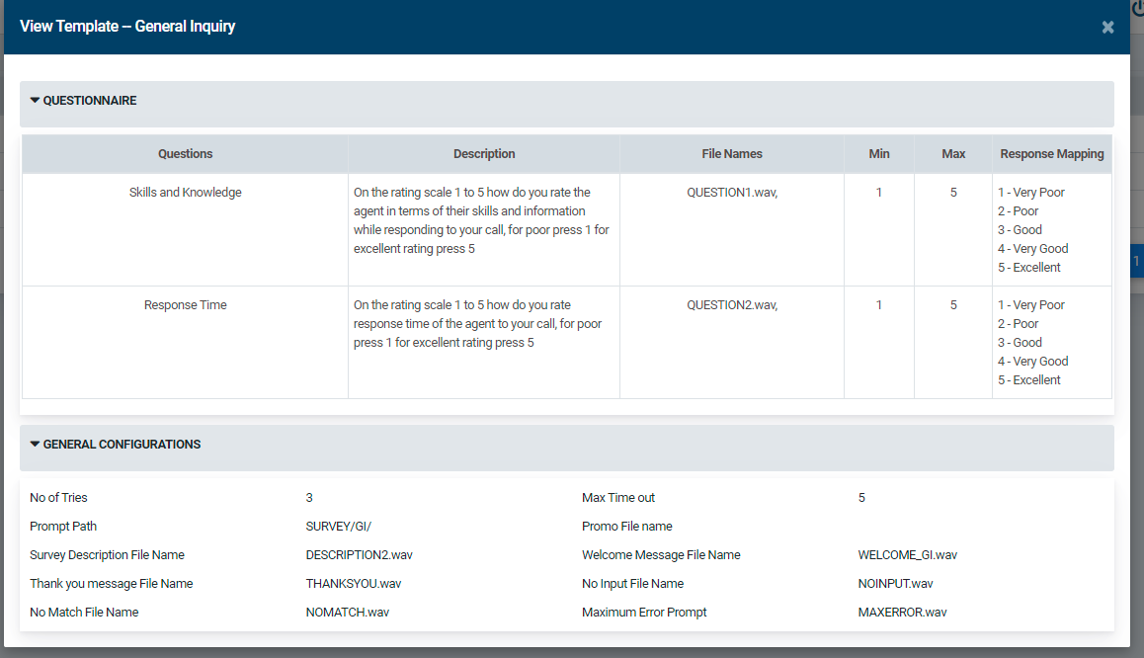

**Sample Question 1:**

1. Very Poor
2. Poor
3. Good
4. Very Good
5. Excellent

**Sample Question 2:**

1. Yes
2. No

**Response Descriptions:**

The list of response descriptions is maintained in separate Master Screen and that would be mapped against each DTMF.

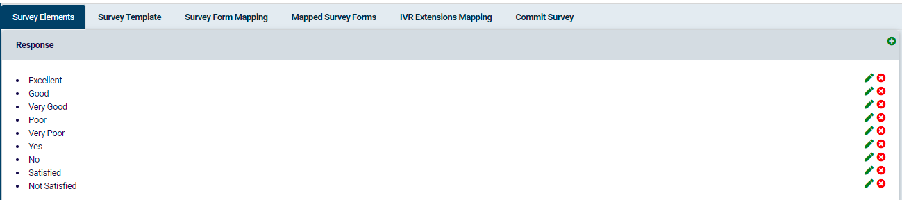

**Manage Engine & SDO integration**

The Cisco UCCX system will be integrated with Manage Engine and SDO using APIs to provide the ticket related details for e.g., Existing ticket status, opening a new ticket history etc. and for authenticating the caller.

**Reporting and Analytics:**

**Survey Reporting**

The following report would be available as part of the admin module to activate the questions

* Summary reports on the customer responses with date ranges.

**Summary Report:**

|  |  |  |  |  |  |
| --- | --- | --- | --- | --- | --- |
| **Summary Report for Customer Responses** | | | | | |
|  |  |  |  |  |  |
| **From Date** | 15-July-23 |  |  | **To Date** | 22-July-23 |
|  | | | | | |
| **Response Description** | **Communication Skills** | **Active Listening** | **Knowledgeable** | **Politeness** | **Problem Solving** |
| **Excellent** | 12 | 29 |  |  | 22 |
| **Very Good** | 20 |  |  |  | 24 |
| **Good** | 30 | 20 |  |  | 10 |
| **Poor** | 10 |  |  |  | 12 |
| **Very Poor** | 2 | 15 |  |  | 25 |
| **Yes** |  |  | 55 |  |  |
| **No** |  |  | 45 |  |  |
| **Satisfied** |  |  |  | 40 |  |
| **Non Satisfied** |  |  |  | 60 |  |

|  |  |
| --- | --- |
|  |  |
| **Question Type** | **Question Description** |
| **Communication Skills** | How would you rate the communication skills of the agent  in the scale of 1 to 5, where 5 represents excellent and 1 represents poor |
| **Active Listening** | How well did the agent understand your question? Please provide your feedback in the scale of 1 to 3, where 3 represents excellent and 1 represents poor |
| **Knowledgeable** | Was the Service Agent Knowledgeable? Press 1 for YES, Press 2 for No |
| **Politeness** | Are you satisfied with the politeness and friendliness of the agent? Press 1 for YES and Press 2 for NO |
| **Problem Solving** | Overall, how would you rate your experience? Please provide your feedback in the scale of 1 to 5, where 5 represents excellent and 1 represents poor |

**Survey Summary Report**

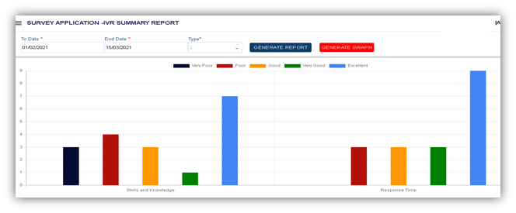

**Note:**

* The above report is based on the customer feedback given during the selected period
* The report is applicable for individual survey
* The color coding used in the above graphical representation is sample. Actual might vary.
* All UI configurations and reports are available only in English language.
* The above report having sample question and responses. Actual values depend on per the questions and responses configured in the Survey module user interface and the customer feedback given in the Survey IVR.

**Cisco Reporting**

**CUIC Reports (out of the Box)**

Cisco Unified Intelligence Center (CUIC) is a web-based reporting application that provides real-time and historical reporting in an easy-to-use, wizard-based application for Cisco Contact Center products. It allows contact center supervisors and business users to report on the details of every contact across all channels in the contact center from a single interface. Cisco Unified Intelligence Center allows customers to extend the boundaries of traditional contact center reporting to an information portal where data can be easily integrated and shared throughout the organization.

Cisco Unified Intelligence Center is a state-of-the-art, open platform offering a secure and unique 360-degree view of the enterprise with the capability to link down, up, or across to other data from any report. Stock and custom reports can be grouped with other web content to create dynamic dashboards. Permanent web links, or permalinks, also enable one-click access to reports and dashboards in Cisco Unified Intelligence Center, allowing reports to be embedded in other dashboards and simplifying access.

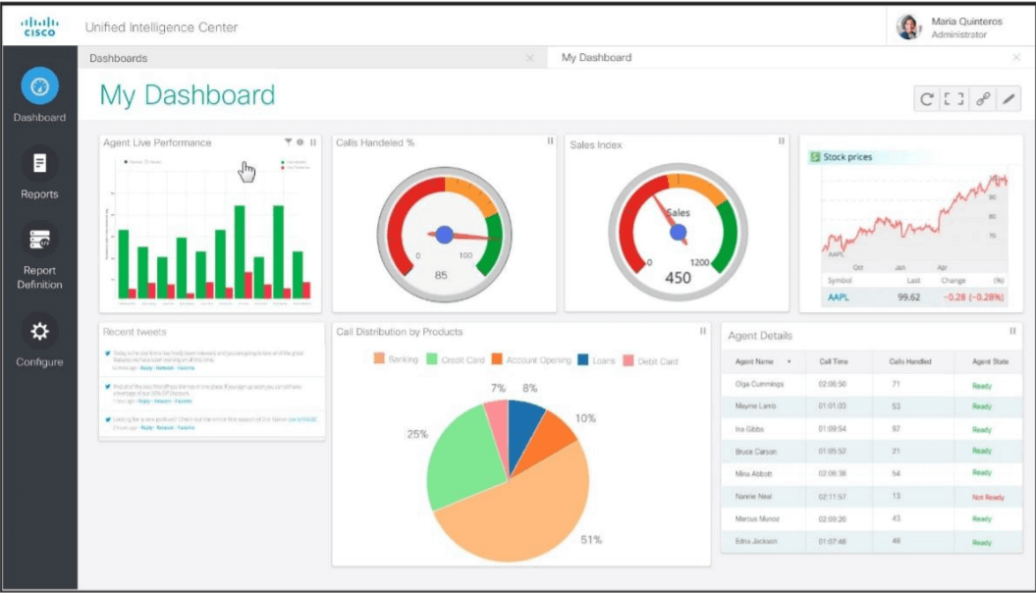

Cisco Unified CCX embeds Cisco Unified Intelligence Center and a set of stock Cisco Unified CCX reports for focused reporting on Cisco Unified CCX.

Features include:

* Cisco Unified Intelligence Center administrative reports
* Dashboards
* Rename columns
* Reorder, hide, and unhide report columns
* Define thresholds (change color, text, and graphics)
* Change report filtering for ad hoc reporting
* Perform partitioning through collections
* Permalinks
* Set individual default values for users or groups that define time zones, languages, and other interface preferences
* Administrators can control access to features, reports, and data by granting privileges only to authorized individual users or groups of users.

**AVAILABLE REPORTS**

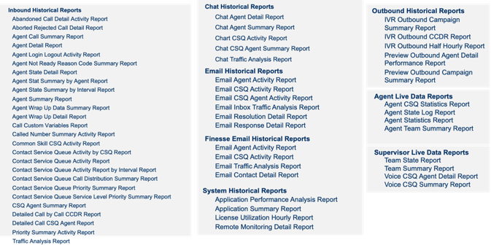

**Realtime Wallboard/ Dashboard:**

The real time dashboards are a software solution that empowers business users and supervisors to deliver information in real-time to every screen needed. A screen doesn't only mean large plasma screens in contact centers and breakrooms, the individual workstations of agents, supervisors, or even managers who are not part of the contact center. The Dashboard supports on all Standard browsers: Chrome, IE, Edge, Mozilla, Safari can be rendered on Tablets, mobile phones, Smart TV’

We understand that agents, supervisors, and managers have different expectations. To meet various team’s requirement, the Dashboards includes a predefined set of key performance indicators (KPIs). The data are stored in the MS SQL server database, thus providing flexibility to customer to create / build your own KPIs.

In line with the business requirements provided, Cognicx is offering wallboard solution suite which can not only meet the current requirements but can also be scaled up for future enhancements and growth. The Dashboards & Wallboards (DW) provided the complete set Real-Time KPIs and grids that can be generated from a UCCX platform. It encompasses hundreds of metrics derived from Key Call Center parameters:

* AGENTS (Contact Service Queues, Teams, Skills, and Sliding Interval)
* CALLS (Contact Service Queues, Applications and Sliding Interval)
* EMAILS (Contact Service Queues and Sliding Interval)
* TEXT (Contact Service Queues and Media Type)
* CHAT (Contact Service Queues, Team, Skills)
* AGENT STATES GRID (Skills, Contact Service Queues and Teams)
* CSQs GRID (Sliding Interval and Contact Service Queues) etc.,

As 2ring dashboard/wallboard is iframe friendly and should be possible to display the layouts in MS dynamics agent desktop this will enable the voice channel related contact center KPI’s to be seen by the supervisors/agents also The MS Dynamics will be updating the interaction data in an SQL server database and from there we will fetch the data associated to the omnichannel interaction KPI’s from the table and show it on the wallboard.

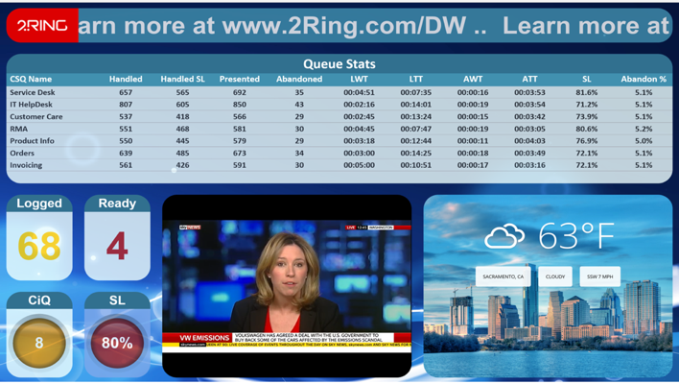**SAMPLE LAYOUT**

PRESENTATION TYPES:

* Single KPIs
  + Numeric or gauges
  + Charts
  + Notifications (visual, audible, email)
* Grids
  + Agents
  + Queues
  + Conditional formatting & notifications
* Ticker
* Calendar

EXTERNAL CONTENT:

Websites

* Weather
* Pictures
* Pdf/ppt
* Data from other applications

**Call recording and Quality management:**

The proposed call recording and quality management solution is powered by Eleveo, which is a part of cisco solution plus component and offers Call Center call recording and Quality Monitoring solutions that are designed to increase revenue and decrease costs by improving your agent and customer engagement while simplifying contact center optimization.

**Call Recording**

Eleveo’s robust call center recording software is designed to provide contact center decision-makers with control over their compliance regime and with the oversight capabilities necessary to manage the quality of agent/customer interactions. Key features for our call and screen recording solutions include:

* **Recording: Record** your interactions. The solution stores recordings in a single database for convenient access. Review and play back calls at any time, so you don’t miss out on vital information.
* **Customizable Configurations:** Configure recording rules based on your needs to archive and categorize large volumes of call data by type, source, and customer. With properly organized datasets, your teams have immediate access to call logs to support their needs.
* **Auto Pause and Resume:** Protect other party’s sensitive information and personal financial information. As the name suggests, Eleveo’s auto-pause feature automatically pauses phone call when sensitive/protected information is being communicated. Its browser-based URL and application detection technology automatically records your customer interactions, pausing audio and screen recording when a URL or application you’ve defined is running (during the exchange of confidential financial data) and resuming after that activity has ended.
* **Live Monitoring:** Listen to customer interactions and evaluate agent performance in real-time.
* **Comprehensive Audits:** Eleveo provides detailed audits for every system activity, such as log-ins, log-outs, executed searches, monitored calls, and shared documents. With this automated tracking mechanism, monitoring activity and conducting proper [compliance](https://www.eleveo.com/compliance) reviews within your contact center will be easier.

**Quality management:**

The Quality Management solution is designed to enable users to monitor and manage agent behavior when working with customers. It comprises of the following features and functionalities

* Role management
* User and Group management
* User interface
* Possibility for group Interactions for Interactions Types
* Categorizing of interactions
* Evaluation forms for rating the caller agent conversation interaction.
* Management reporting and dashboards

# **Detailed Scope of Work**

Scope of work includes the following:

* 1. **Project Planning**
* During the project planning phase the High Level Project Plan (HLPP) will be presented to the stakeholders and based on the feedback will be submitted for the HLPP signoff.

**Deliverable (Project Planning)**

High Level Project Plan

* 1. **Project Requirements**
* A detailed requirement analysis will be carried out, during which requirement gathering/walkthrough sessions will be conducted by Business Analysts with EDGE users. A Functional Specification Document (FSD) will be prepared and submitted based on the outcome of these discussions.
* All the functional requirements from the users, for all the phases including, IVR call flows, integration with Manage engine, SDO, that will be documented as part of scope in terms of functional requirements. All the requirements that the solution offers and requested by EDGE users will be documented. The entire process and flow will be defined during this phase.
* All the technical touch points like system architecture, endpoint integration, communication mechanisms will all be defined this phase. Any additional configurations required for the solutions to run will also be covered as part of this document.
* Specific integration details with Manage Engine for customer information to provide as screen pop will all be covered in this document.

**Deliverables (Requirements)**

* Functional Specification Document
  1. **Design, Development & Testing**
* IVR application including Call back & call survey module.
* Cisco UCCX Configuration

**Deliverables (Design, Development & Testing)**

* Code Delivery, Installation and configuration Guide, Vendor Integration
* Test Scripts and results
  1. **License delivery**

**Production setup**

* Cisco UCCX contact center platform for 15 agent licenses.
* Call back module for 15 agents.
* Call survey module for 15 agents.
* 15 agent licenses for real time dashboard and wallboard.
* Call recording and Quality management licenses for 15 agents.
  1. **Implementation & Testing**
* Configuring cisco gear
* Integration of Cisco UCCX with Manage Engine and SDO using API’s.
* Implementation of real-time dashboard and wallboard.
* Implementation of Call recording and Quality management
* Configurations - All the proposed solution related features functionalities as per the FSD will be configured.

**Deliverables (Implementation & Configurations)**

* Deploy solution in the Production setup. The deployable will be manually deployed/ copied to the production environment with necessary changes in configuration.
  1. **UAT (Production Set-up)**
* UAT Support, Security Testing Support, Performance Testing Support, Bug fixes (including Release Management Process deliverables such as release notes and activity checklist), deployment guide.
* Setup launch for limited users in production environment servers.
* Production support

**Deliverables (UAT)**

* System Integration Testing
  + All integration points like, Manage Engine, SDO will be tested in this phase, meeting all business scenarios.
* Support EDGE for User Acceptance Test
  1. **Go Live, Orientation and Handover**
* Go live, full production after go-ahead from users.
* Applications walk-through
* User Manuals/guide for
  + IVR application
  + Realtime dashboard and wallboard
  + CUIC Reporting voice
* Warranty Support (2 weeks post go live)

**Deliverables (Go live, Orientation and Handover)**

* Project management plan
* Functional Specifications Document
* Admin and operational manual
* Application Executable(s)
* General Support and bug fixes including release management process deliverables such as release notes and activity checklist.

* 1. **Training**

A knowledge transfer is provided to get oriented towards the components/modules delivered as part of this solution. The aim of the consultants would be to provide a walkthrough of the solution to the EDGE IT and operations team. We will conduct this training for a period of 5 days during the production cutover stage.

**Hardware/Software requirements and pre requisites for the solution**

The hardware, software, database has to be provided by the Client. The complete details will be shared before the implementation stage, and we have considered production setup only. For other application & database server or any other Server (virtual machine) requirement details like Resources required, OS, and DB requirement details will be shared during design stage as part of Site readiness document \ pre-requisites, same to be provided by EDGE.

**VM SPECIFICATION**

**Cisco UCCX:** Cisco UCCX servers with HA license and Premium seat licenses.

Required HW Spec for UCCX 12.5:

1. vCPU: 2
2. RAM: 10 GB
3. vDisk: 146 GB

Virtualization platform: VMWare ESXi 7.0 (can be deployed on ESXi 6.5 and 6.7 as well however these ESXI versions have reached end of life and it is recommended to deploy on 7.0)

Note: We will leverage existing production CUCM cluster environment (which is managed by Edge). If EDGE requires dedicated CUCM cluster to be deployed Edge to provide the required HW virtualization resources and licenses.

Voice gateway with PRI\SIP with channels as per call volume requirement. The contact centre solution will leverage existing Voice gateway or CUBE (managed by Edge) However, the service provider connectivity (PRI or SIP) to be ensured by EDGE Team – It is required to have dedicated PRI\SIP channels from service provider for contact centre as per expected call volume.

**Integration Server**

|  |  |  |  |  |  |  |  |
| --- | --- | --- | --- | --- | --- | --- | --- |
| **Component** | **OS** | **Database** | **No of VMs** | **Per VM** | | | |
| **vCPU** | **vRAM** | **Storage (GB)** | **vNIC** |
| Custom-App\Reporting | windows Server 2019 | MySQL | 2 | 4 | 32 | C: 60 D: 200 | 1 |

**Realtime dashboard and wallboard & CUIC Reporting**

|  |  |  |  |  |  |  |  |
| --- | --- | --- | --- | --- | --- | --- | --- |
| **Component** | **OS** | **Database** | **No of VMs** | **Per VM** | | | |
| **vCPU** | **vRAM** | **Storage (GB)** | **vNIC** |
| 2Ring | NA | NA | 2 | 4 | 32 | 256 | 1 |
| Manage Engine and 2Ring integration | windows Server 2019 | MySQL | 2 | 4 | 32 | 256 | 1 |

**Eleveo Suite**

|  |  |  |  |  |  |  |  |  |  |  |  |  |  |  |  |  |
| --- | --- | --- | --- | --- | --- | --- | --- | --- | --- | --- | --- | --- | --- | --- | --- | --- |
| **Capturing Cluster DC-A** | | |  |  |  |  |  |  |  |  |  |  |  |  |  |  |
| **NAME** | **vCPU [-]** | **MEMORY [GB]** | **Storage Requirements** | | | | | | **Server Role** | **COMPONENTS [-]** | | | | | | |
| **HDD-System-DB-Media [GB]** | **HDD-System-DB-Media [IOPS]** |  |  |  |  |
| **SRV1** | 6 | 16 | 150 | 125 |  |  |  |  | Recorder | DB, WEB UI, TOOLS, CM, CORE, JTAPI, UCCX IM, SLR, DECODER, SCREENREC, SCREENREC MEDIA UPLOADER | | | | | | |
| **Capturing Cluster DC-B** | | |  |  |  |  |  |  |  |  |  |  |  |  |  |  |
| **NAME** | **vCPU [-]** | **MEMORY [GB]** | **Storage Requirements** | | | | | | **Server Role** | **COMPONENTS [-]** | | | | | | |
| **HDD-System-DB-Media [GB]** | **HDD-System-DB-Media [IOPS]** |  |  |  |  |
| **SRV1** | 6 | 16 | 150 | 125 |  |  |  |  | Recorder | DB, WEB UI, TOOLS, CM, CORE, JTAPI, UCCX IM, SLR, DECODER, SCREENREC, SCREENREC MEDIA UPLOADER | | | | | | |
| **Replay Server (DC)** | | |  |  |  |  |  |  |  |  |  |  |  |  |  |  |
| **NAME** | **vCPU [-]** | **MEMORY [GB]** | **Storage Requirements** | | | | | | **Server Role** | **COMPONENTS [-]** | | | | | | |
| **HDD-System-DB [GB]** | **HDD-System-DB [IOPS]** | **Media NAS/SAN [GB]** | **Media NAS/SAN [IOPS]** | **Media Archive NAS [GB]** | **Media Archive NAS [IOPS]** |
| **SRV1** | 6 | 24 | 150 | 125 | 2150 | 75 | N/A | N/A | Replay Server | DB, WEB UI, TOOLS, CM, CORE | | | | | | |

|  |
| --- |
| **Virtualization Considerations** |

* VMware ESX/ESXi 6.5 and later are supported
* CPU resources must be reserved for each machine (CPU frequency to be reserved, vCPUs to be mapped to physical cores).
* Memory resources must be reserved for each machine.
* Redundancy for virtual HDDs is provided the level of the SAN.
* VMware Tools must be installed on each machine and be up to date.
* Physical servers must have Intel CPU E5-26XX v2 2.5Ghz or higher
* I/O throughput is guaranteed (Average Disk sec/Read Write of less than 10ms)
* Usage of VMXNET 3 network card type is strongly recommended (A corresponding vmxnet3 driver must be used by the network card(s) within the Linux system).
* Virtual Hard Drive controller: VMware Paravirtual
* It is highly recommended that the iputils package should be upgraded to the latest version (more info: http://rhn.redhat.com/errata/RHBA-2013-1290.html).

|  |  |  |
| --- | --- | --- |
| **SAN requirements for VMs:** |  |  |

* Data Store will use low latency connection (Fiber Channel or iSCSI)
* RAID controller used for storage and VM HDDs has at least 512MB of cache
* Storage will consist of SAS 15k rpm HDDs

**SAN requirements for Interaction Storage:**

* Data Store will use low latency connection (Fiber Channel or iSCSI)
* RAID controller used for storage and VM HDDs has at least 512MB of cache
* Storage will consist of SAS 15k rpm HDDs.

# **High Level Deployment Timelines**

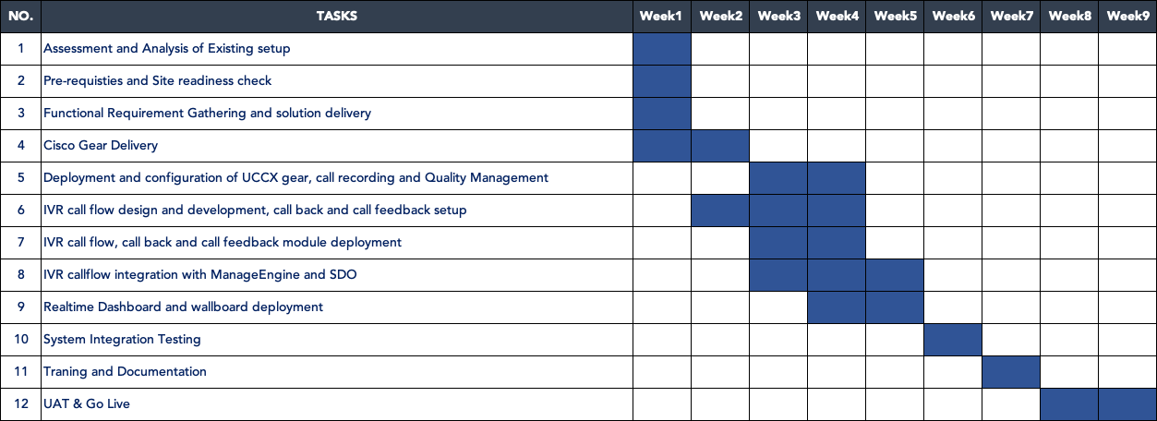The following table describes high level project schedule for the requirements, the project will be initiated 2 weeks post the executed work contract. The detailed project plan will be created and distributed during the project kickoff stage.

**Resource Allocation**

**For the duration of the project the following chart depicts the resource allocation for the complete solution deployment and integrations as per the scope requirements.**

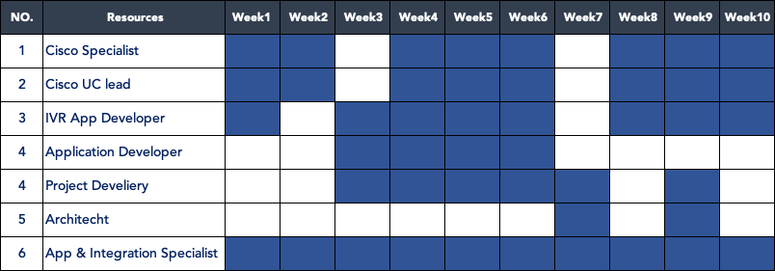

# **Governance Model**

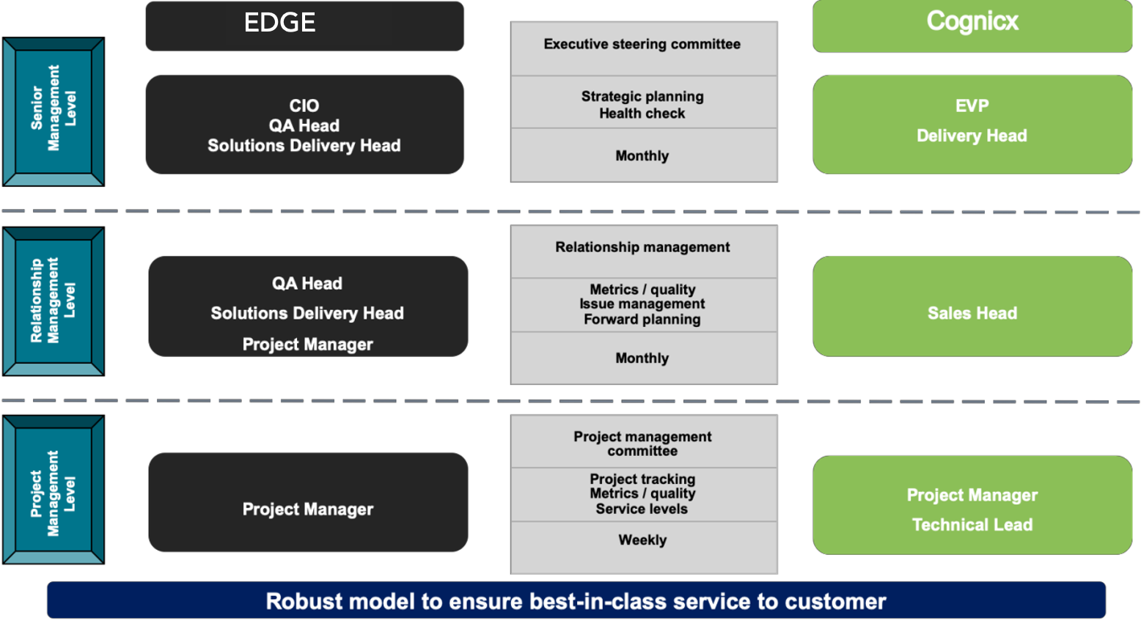

# **Key points to note and Dependencies**

**Following are the assumptions considered:**

* UCCX: Edge will provide the required server\virtualization resources for the deployment of UCCX servers.
* VG and CUCM: As per last communication with Edge (Anas) the contact centre solution will leverage existing prod CUCM cluster environment and voice gateway.
* PRI \ SIP:  dedicated Carrier channel (PRI or SIP) required for contact centre calls (as per expected call volume) to be provided by Edge.
* Windows, SQL to be provided by Edge
* The call flow will be developed in English & Arabic language only.
* IVR voice prompt recording to be done and provided by EDGE.
* We will be consuming the restful APIs for the services to be developed as provided by EDGE team.
* EDGE need to share the APIs for us to check and validate. during the Solution discovery stage, we will map parameters with the API output.
* Database provisioning, administration & maintenance will be the responsibility of EDGE.
* EDGE to provide API details and support for integrating with Manage Engine & SDO
* EDGE will develop user test plans, scripts and data that will be used for UAT.
* For Cisco UCCX we will use the existing call manager and gateway. In case Edge wants to have it separate from the IP telephony then that needs to be quoted for separately.
* We will be working jointly with the EDGE PMO team to complete the design, installation, configuration, and testing of the proposed solutions.
* Load testing & stress testing is not considered in this scope of engagement.
* Windows & DB licenses to be provided by Client.
* All the development and related services will take place during standard business hours of 9 AM to 6 PM excluding Saturdays, Sundays, and public holidays, unless specifically stated otherwise herein.
* Security clearance for access to Client facilities (facilities security access card, etc.), all required passwords (Windows Administrator, etc.), access to telephones with outside lines, a PSTN connection with dialing facilities, Internet connection, a copier and normal office supplies as needed.
* All pictures in this document are for illustration purposes.

# **ANNEXURE A: SUPPORT SERVICES**

**Overview of the Support Services Engagement**

Cognicx Support Services goes beyond enterprises to garner continuous benefits from their IT investments: in the contact center and collaboration solutions deployed. Our support services will ensure that your systems are always available to deliver the desired business outcome.

Support Services Overview: following services are included in the scope.

| **Support Services** | **Services** |
| --- | --- |
| Support Coverage (On-call, Onsite) | 24x7 |
| Public Holidays | On call, onsite based on the issue Priority. |
| Break-Fix /Reactive Services | |
| Service Desk: | Single point of contact (SPOC) for all Client queries, incidents, issues, resolutions. Reachable via email. |
| Level 1 support. | Provide Incident detection, recording, classification, investigation, diagnostics, restoration, and closure. |
| Level 2 support. | Identify problems, known errors, changes to resolve problems, or provide a workaround. |
| Incident Reporting (Monthly) | Periodically track, and report incidents / Changes. |
| Third Party Product support: | Handling & managing L1 and basic L2 support for Cisco solution. Coordination and follow up with Cisco for L2/L3 issues including product issues, product upgrades & patches. |
| Preventive Services | |
| Review (Monthly) | Periodically perform preventive maintenance activities on the solution. Activities include Backup, Service Restart, and Server Housekeeping & Failover testing.  Provide a health check report on the solution. The report contains current software versions, patch updates, performance metrics and recommendations. |
| Updates & Patch Management (Monthly) | Update system/solution with latest software updates and patches for the currently installed version. |
| Service Level Management | |
| Incident SLA – Response | 30 minutes over telephone |
| SLA Reporting | Monthly report on SLA. |
| Governance | |
| Review Meet: (Quarterly) | Periodic meeting to review & discuss the support activities (engagement) happening on the solution under scope and discuss the action items moving ahead. |

**Service Request Priority Level Details:**

|  |  |  |  |
| --- | --- | --- | --- |
| **Urgency** | **Description** | **Response Time** | **Resolution Time** |
| High | Critical for daily operations | 1 Hour | 5 hours |
| Medium | Daily Operations, visibility to business | 2 hours | 8 hours |
| Low | Planned agreed activity | 4 hours | 16 hours |

**Incident Priority Level Details:**

|  |  |  |  |
| --- | --- | --- | --- |
| **Urgency** | **Description** | **Response Time** | **Resolution Time** |
| Critical | System no longer work | 15 min | 4 hours |
| High | Daily Operations, visibility to business | 1 Hour | 5 hours |
| Medium | Daily Operations, visibility to business | 2 hours | 8 hours |
| Low | Planned agreed activity | 4 hours | 16 hours |

Service Delivery Model

The Support & Maintenance Services will be delivered in an On-call, Onsite support based on the priority of the incident.

**Our Service Delivery Model**

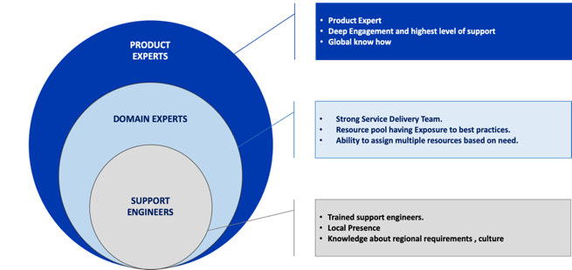

**Engagement: Operational Activities and Steps**

The Overall Operational Activities, steps involved during the Support and Maintenance engagement are as follows:

Step 1: Faults / Incidents / Tickets will be reported to the helpdesk via:

* email (For tickets logging please mail: [support@cognicx.com](mailto:support@cognicx.com)

The stakeholders can raise faults/incidents /ticket with our service desk.

* Support helpdesk (Client)
* Client’s IT Team

Step 2: Once raised, the Support engineer and relevant stakeholders at Client end will get notifications via email/SMS alerts.

Step 3: The support engineer will initiate corrective action and establish response priorities based on the Priority level of the problem and agreed timeframes as decided.

Step 4: If the incident is a Problem, then the support engineer will engage the product team.

Step 5: If the incident is a Change, Change Management process will be followed to implement the Change Request.

The following table provides the escalation matrix in the event issues are not responded within the time frame specified below:

|  |  |  |  |
| --- | --- | --- | --- |
| **Elapsed Time After a Problem is Reported** | **Priority 1** | **Priority 2** | **Priority 3** |
| 2 Hours | Technical Manager | --- | --- |
| 4 Hours | Service Manger | Technical Manager | --- |
| 5 Hours | General manager | Service Manger | --- |
| 12 Hours | --- | General manager | Technical manager |
| 24 Hours | --- | --- | Service Manager |

Note: The Contact details, email ids will be provided during the support engagement initiation stage.

# **ANNEXURE B: CISCO BOQ for 15 Agents**

|  |  |  |  |  |
| --- | --- | --- | --- | --- |
| **Line Number** | **Part Number** | **Smart Account Mandatory** | **Description** | **Qty** |
| **1.0** | **A-FLEX-3-CC** | - | Flex 3.0 for Contact Center | 1 |
| Initial Term - 12.00 Months | Auto Renewal Term - 0 Months | Billing Model - Prepaid Term | Requested Start Date - 20-Aug-2023 | Requested End Date - 19-Aug-2024 | Advance Drawdown - 0 | | | | |
| 1.1 | A-FLEX-05-12.5-K9 | - | On-Premises UCCX Std & Prem Media Kit v12.5 | 1 |
| 1.2 | A-FLEX-CCX-P-AGT | Yes | On-Premises UCCX Premium Agent License Smart Licensing | 15 |
| 1.3 | A-FLEX-CCX-SVR | Yes | On-Premises UCCX Standard & Premium Server Smart Licensing | 1 |
| 1.4 | A-FLEX-CCX-P-C | - | On-Premises UCCX Premium Concurrent Agent | 15 |
| 1.5 | SVS-CSS-SUPT-SSPT | - | Solution Support for Collaboration | 1 |
| **2.0** | **ELEVEO-SB** | - | SolutionsPlus: Eleveo (Zoom) Onprem Subscription Billing | 1 |
| Initial Term - 12.00 Months | Auto Renewal Term - 12 Months | Billing Model - Prepaid Term | Requested Start Date - 20-Aug-2023 | Requested End Date - 19-Aug-2024 | Advance Drawdown - 0 | | | | |
| 2.1 | ZI-QM-AQM-1Y | - | Eleveo Advanced Quality MgmtBundle for UCCX UCCE (per seat) | 15 |
| 2.2 | ZI-HA-CR-1Y | - | Eleveo High Availability for Call Rec (Per Seat, Call) | 15 |
| **3.0** | **2RING-SB** | - | SolutionsPlus: 2Ring Subscription (Self-Hosted) | 1 |
| Initial Term - 12.00 Months | Auto Renewal Term - 0 Months | Billing Model - Prepaid Term | Requested Start Date - 20-Aug-2023 | Requested End Date - 19-Aug-2024 | Advance Drawdown - 0 | | | | |
| 3.1 | 2RS-DW | - | 2Ring Dashboards & Wallboards (DW) | 15 |

**OPTIONAL CISCO BOQ**

In case EDGE is looking for procuring server switch and voice gateway for contact center and not leverage their existing setup following is the BOQ they need to consider. We have not included the same into the commercials and this is merely indicative BoQ. The final BOQ can be discussed during the finalization stage.

| **Line Number** | **Part Number** | **Smart Account Mandatory** | **Description** | **Qty** |
| --- | --- | --- | --- | --- |
| **4.0** | **C8200L-1N-4T** | - | Cisco Catalyst 8200L with 1-NIM slot and 4x1G WAN ports | 2 |
| 4.0.1 | CON-SSSNT-C8200TL1 | - | SOLN SUPP 8X5XNBD Cisco Catalyst 8200L with 1-NIM slot and | 2 |
| 4.1 | MEM-C8200-4GB | - | Cisco Catalyst 8200 Edge 4GB memory | 2 |
| 4.2 | C-RFID-1R | - | Cisco Catalyst 8000 Edge RFID - 1RU | 2 |
| 4.3 | C8200-RM-19-1R | - | Cisco Catalyst 8200 Rack mount kit - 19" 1R | 2 |
| 4.4 | NETWORK-PNP-LIC | Yes | Network Plug-n-Play Connect for zero-touch device deployment | 2 |
| 4.5 | C8200-PIM-BLANK | - | Cisco Catalyst 8200 Edge PIM Blank | 2 |
| 4.6 | C-M2-BLANK | - | Cisco Catalyst 8000 Edge M.2 Blank Cover | 2 |
| 4.7 | IOSXE-AUTO-MODE | - | IOS XE Autonomous boot up mode for Unified image | 2 |
| 4.8 | PWR-CC1-150WAC | - | Cisco C8200 1RU AC 150W PoE Power supply | 2 |
| 4.9 | CAB-ACU | - | AC Power Cord (UK), C13, BS 1363, 2.5m | 4 |
| 4.10 | NIM-1MFT-T1/E1 | - | 1 port Multiflex Trunk Voice/Clear-channel Data T1/E1 Module | 2 |
| 4.11 | PVDM4-32 | - | 32-channel DSP module | 2 |
| 4.12 | SC8KBEUK9-176 | - | UNIVERSAL | 2 |
| 4.13 | DNA-P-T0-A-3Y | Yes | Cisco DNA Advantage On-Prem Lic 3Y - upto 25M (Aggr, 50M) | 2 |
| **Initial Term - 36.00 Months | Auto Renewal Term - 0 Months | Billing Model - Prepaid Term | Advance Drawdown - 0** | | | | |
| 4.14 | SVS-PDNA-T0-A3Y | - | Solution Support for SW - DNA Advantage OnPrem Lic, T0, 3Y | 2 |
| **Initial Term - 36.00 Months | Auto Renewal Term - 0 Months | Billing Model - Prepaid Term | Advance Drawdown - 0** | | | | |
| 4.15 | DSTACK-T0-A | Yes | Cisco DNA Advantage Stack - upto 25M (Aggr, 50M) | 2 |
| **Initial Term - 36.00 Months | Auto Renewal Term - 0 Months | Billing Model - Prepaid Term | Advance Drawdown - 0** | | | | |
| 4.16 | NWSTACK-T0-A | Yes | Cisco Network Advantage Stack - upto 25M (Aggr, 50M) | 2 |
| **Initial Term - 36.00 Months | Auto Renewal Term - 0 Months | Billing Model - Prepaid Term | Advance Drawdown - 0** | | | | |
| 4.17 | TE-EMBED-WANI | Yes | Cisco ThousandEyes WAN Insights Embedded | 2 |
| **Initial Term - 36.00 Months | Auto Renewal Term - 0 Months | Billing Model - Prepaid Term | Advance Drawdown - 0** | | | | |
| 4.18 | SDWAN-UMB-ADV | Yes | Cisco Umbrella for DNA Advantage | 2 |
| **Initial Term - 36.00 Months | Auto Renewal Term - 0 Months | Billing Model - Prepaid Term | Advance Drawdown - 0** | | | | |
| 4.19 | DNAC-ONPREM-PF | - | Cisco DNA Center On Prem Deployment Option for WAN | 2 |
| **Initial Term - 36.00 Months | Auto Renewal Term - 0 Months | Billing Model - Prepaid Term | Advance Drawdown - 0** | | | | |
| 4.20 | C82L-1N-4T-PF | Yes | C8200L-1N-4T Platform Selection for DNA Subscription | 2 |
| **Initial Term - 36.00 Months | Auto Renewal Term - 0 Months | Billing Model - Prepaid Term | Advance Drawdown - 0** | | | | |
| 4.21 | IOSXE-AUTO-MODE-PF | Yes | IOS XE Autonomous boot up mode for Unified image | 2 |
| **Initial Term - 36.00 Months | Auto Renewal Term - 0 Months | Billing Model - Prepaid Term | Advance Drawdown - 0** | | | | |
| **5.0** | **BE6K-M6-K9** | - | Cisco Business Edition 6000 (M6) Appliance, Export Restr SW | 2 |
| 5.0.1 | CON-SNT-BE6K6KHW | - | SNTC-8X5XNBD Cisco Business Edition 6000 (M6) Applian | 2 |
| 5.1 | CAB-9K10A-UK | - | Power Cord, 250VAC 10A BS1363 Plug (13 A fuse), UK | 4 |
| 5.2 | VIRT-LIC-NONE | - | Do not factory-load a virtualization software license | 2 |
| 5.3 | BE6K-CPU-M6 | - | Intel 4310T 2.3GHz/105W 10C/15MB DDR4 2667MHz | 2 |
| 5.4 | BE6K-RAM-M6-M5 | - | 16GB RDIMM SRx4 3200 (8Gb) | 8 |
| 5.5 | BE6K-RAIDCTRLR-M6 | - | Cisco 12G SAS RAID Controller w/4GB FBWC (16 Drv) w/1U Brkt | 2 |
| 5.6 | BE6K-DISK-M6 | - | 600GB 12G SAS 10K RPM SFF HDD | 12 |
| 5.7 | BE6K-PSU-M6 | - | Cisco UCS 1050W AC Power Supply for Rack Server | 4 |
| 5.8 | BE6K-TPM-M6 | - | TPM 2.0, TCG, FIPS140-2, CC EAL4+ Certified, for M6 servers | 2 |
| **6.0** | **VMW-VSP-STD-1A=** | - | VMware vSphere 8 Std (1 CPU, 32 Core) 1-yr, Support Required | 2 |
| 6.0.1 | CON-ISV1-VSXSTD1A | - | VSphere Standard for 1 CPU; ANNUAL List 1-YR Reqd | 2 |
| 6.1 | UCS-VMW-TERMS | - | Acceptance of Terms, Standalone VMW License for UCS Servers | 2 |

# **ANNEXURE C: COMPLETED PARTC-BIDDER RESPONSE DOCUMENT**

**Company Background and Resources**

Cognicx, an organization, Founded in 2018, focusing on Cognitive Customer Experience, through Secure and Integrated Digital Offerings, across various industries. We are Focused on adding Business value through Consulting and Digital Engagements. Expertise in Customer Journey Design and Digital Transformation. Cognicx is CX focused and following are the areas of engagement with an enterprise:

* Customer Journey Design
* Omnichannel Customer Engagement
* Decision Supporting Engine
* Conversational AI
* Speech Analytics Solution
* Real-Time Interaction Management
* Proactive Application Monitoring
* Feedback Management System
* Complaint Management System
* Process Automation
* Video KYC Application
* Digital On-boarding

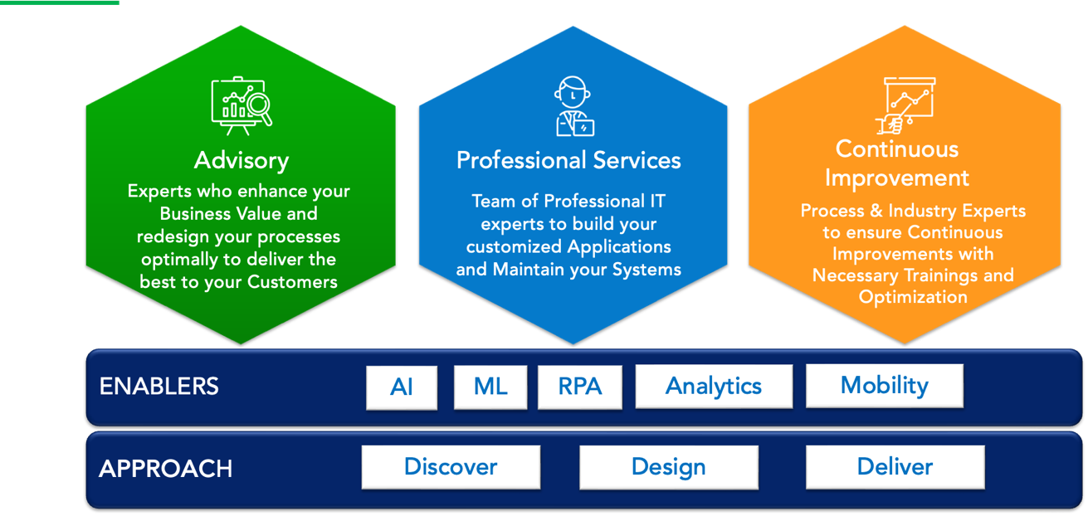**Capacity and Capabilities:**

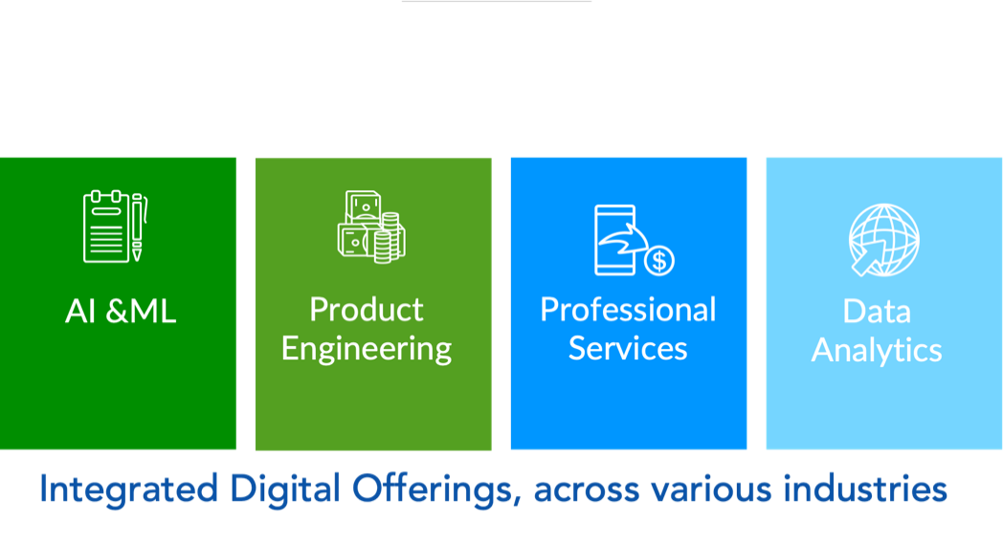

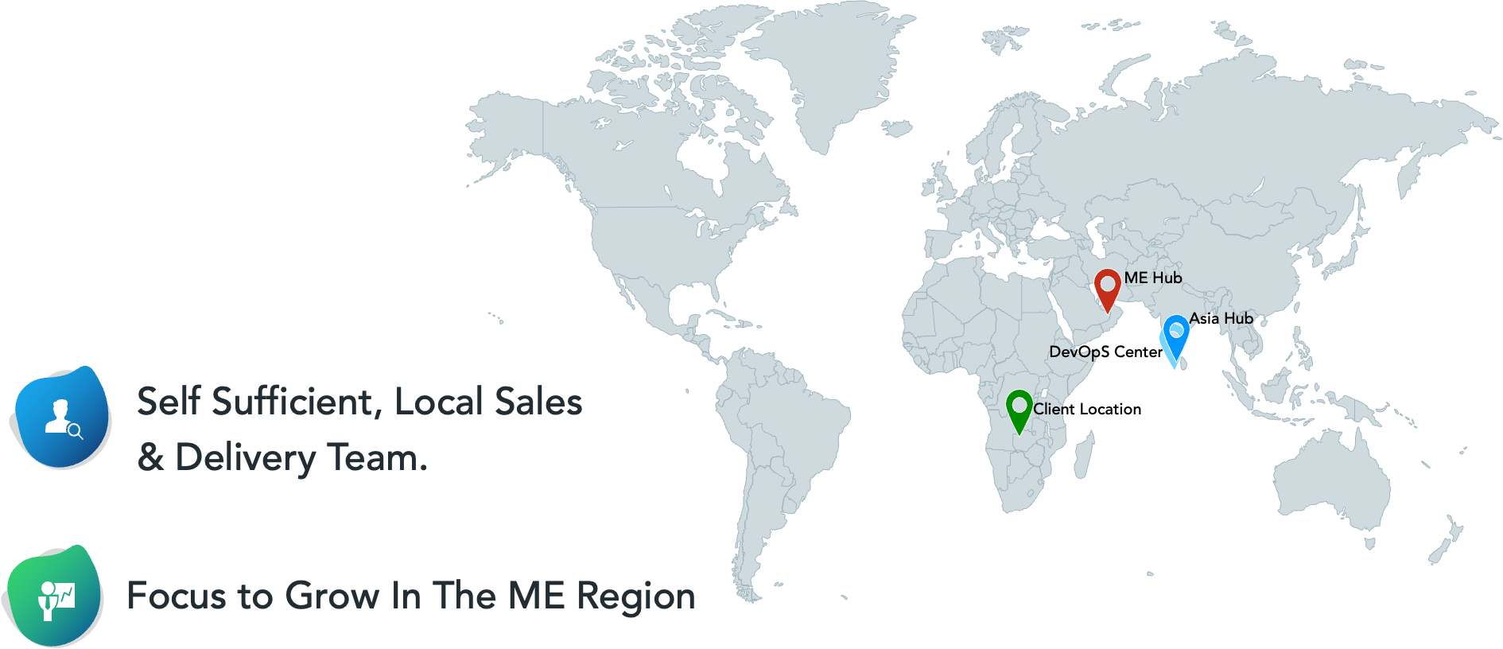

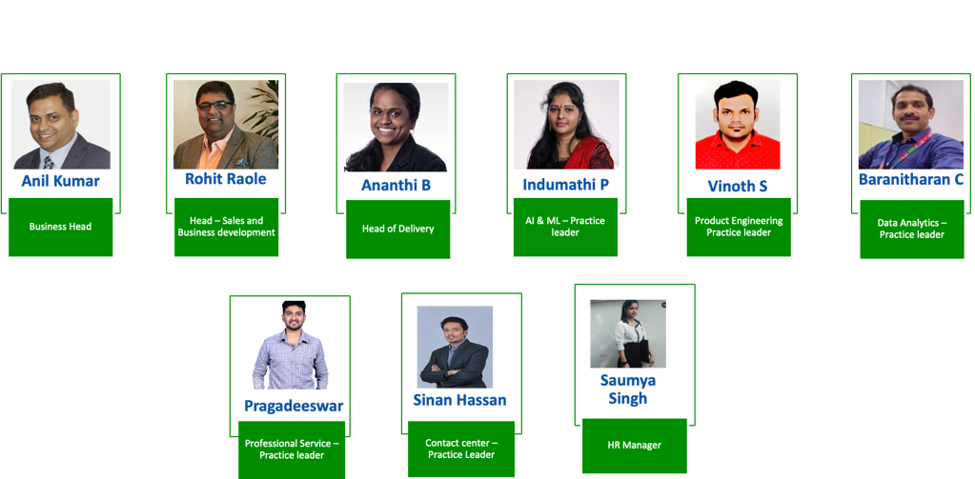Around 50 member team focused in only CX domain with around 20 associates that includes, sales, presales, support, subject matter experts, project delivery onsite, analysts, architect, project managers and admin in UAE and 30 of our off shore delivery associates including developers’ testers, business analysts based in India. The Key members are as mentioned below:

# **ANNEXURE D: TEAM COMPOSITIONS AND ASSOCIATES CV’s**

Following will be the team composition for the project engagement along with the details of their roles and responsibilities.

Roles & Responsibilities:

After official confirmation of the LPO/commercial contract for the implementation services, the Cognicx team will be assigned to the project. The following is a representative team structure:

Project Manager

The Cognicx project manager will be the day-to-day Cognicx lead on the individual work-schedules and is the single customer point of contact for reporting and tracking status for the work-schedules. The Cognicx project manager has the responsibility for identifying and securing Cognicx resources for the work-schedules.

The Cognicx project manager is responsible for managing the scope of Cognicx involvement in the Project. The Project Manager also works with the EDGE Project Managers to manage project scope and manage the delivery of project deliverables per the mutually agreed upon project plan.

The Cognicx project manager is available to lead and facilitate project meetings, such as business requirements gathering sessions and data definition sessions. Responsibilities include, but are not limited to:

* Interact with other Project Manager(s) assigned to this project.
* Manage Cognicx overall work-schedule plan.
* Coordination Plan of Resources/ Roles and Responsibilities.
* The Project Timelines related to the project.
* Weekly status report.
* The Change Control Process relating to the project.
* Document and manage Issue Escalation Process within the control of Cognicx or its Business Partners.
* Project Execution Strategy relating to the project.
* Post Project Review.
* Identify potential issues and delivery risks (including any issues lists).
* Suggest mitigating actions to address work-schedule risks.

Business Analyst

The Cognicx business analyst will be responsible for championing the requirements document preparation for EDGE. Responsibilities include, but are not limited to:

* Interact with customer personnel at various levels to gather the requirements.
* Conduct customer meetings to understand the current system and gather requirements.
* Interact with other team lead(s) assigned to this project.
* Prepare the Project Requirements Document

Team Lead

The Cognicx team lead will be responsible for overseeing all the custom applications, routing rules and scripts developed for EDGE. Responsibilities include, but are not limited to:

* Interact with other team lead(s) assigned to this project.
* Manage developers assigned to this project.
* Design and deliver the various custom applications.
* Coordination Plan of Resources/ Roles and Responsibilities

Developer

The Cognicx developer will be responsible for the development of various custom applications as per the design. Responsibilities include, but are not limited to:

* Interact with other team lead(s) assigned to this project.
* Develop the various custom applications.
* Unit test the various custom applications.
* Integrate and test the various custom applications.
* Provide bug-fix for the developed custom applications.

Tester

The Cognicx Testing lead will be responsible for overseeing all the testing and quality control procedures. The quality assurance lead will be responsible for the test case preparation and test case execution. Responsibilities include, but are not limited to:

* Interact with other team lead(s) assigned to this project.
* Manage test case preparation.
* Manage test case execution.
* Test Plan Review, User Acceptance Test Plan Review and Update

Cisco Engineer

The Cognicx network consultation engineer will be responsible for implementation of all the Cisco components in EDGE. Responsibilities include, but are not limited to:

* Coordination Plan of Resources/ Roles and Responsibilities.
* Weekly status report.
* Document and manage Issue Escalation Process within the control of Cognicx or its Business Partners.

**CV’S OF THE ASSOCIATES NOMINATED FOR THE PROJECT**

**PROJECT DELIVERY MANAGER**

**Professional Summary**

* Overall **10+** years of experience in **Java** Programming.
* Domain experiences: **Insurance, BPO, HRMS, Travel, CMS**
* Experienced in **JAVA Backend Development**
* Cloud Platform: **AWS Services**.
* Experience in **Monolithic & Microservices Architecture.**
* Background in all phases of software engineering including **Analysis, Design, Coding, Testing**, and **Implementation** as well as Agile Software Development using **Jira** and **Git**.
* Experience in **Spring Boot Modules**, **Spring Security**, **Spring Actuator**, **Eureka Registry** & **Discovery Client**, **Spring Data JPA**, **Spring Rest, Zuul**.
* Experience in Mysql, MS-SQL, and Oracle databases.

**Skills**

* Technologies -Java, Spring Boot, JPA, Nodejs, AWS
* Databases- MySQL, MSSQL, Oracle
* IDE- Eclipse, STS, Visual Studio Code
* Tools- Tortoise SVN, Git, Putty, Postman

**Key Projects Summary:**

**Project 1: IQUMEX**

* Involved in requirement analysis, design, development, Testing, and bug fixing.
* Responsible for deployment of all the modules in AWS.
* Responsible for creating the EC2 instance, RDS, and S3 bucket and maintaining all the project activities in AWS.
* Work with external teams and/or vendors for the deliverables.
* Provide production support, deploying the services in ECS and DB backup.

**Project 2: EMS**

* Customer shall send an email to a designated support email address. A supervisor shall monitor the support email box and move the emails to the respective email folders depending on the nature of support.
* The customer’s name, email, message sent time, Subject, Body, Attachments, Support Group, and Case id shall be stored in a DB and the email shall be queued for processing.
* The Email Processing Engine shall identify the best agent for handling the email.
* Emails are routed to agents using IMAP Protocol.

**Education**

B. Tech (IT) - SBC Engineering College with 74%.

**CISCO CONTACT CENTER SPECIALIST**

**Professional Summary**

A Contact center specialist with over 8 years of experience and expertise in designing, implementing a complete infrastructure for Contact Center solutions across the globe, and handling the post-production support. Technology professional who is always striving for excellence and innovation in a creative and unique way. An effective communicator with excellent relationship management and always ahead in grasping new technical concepts quickly and utilizing them in an effective manner**.**

**Skills:**

* Cisco contact Centre Solutions: UCCX, PCCE, UCCE, WebxCC
* Cisco Collaboration suits
* OnPrem Collaboration: CUCM, CUC, IMP, UCCX, Jabber, Voice Gateways and CUBE
* Edge Collaboration: VCS, Expressway Edge & Core
* Cloud Collaboration: WebEx Teams, Control Hub, Hybrid Services & Webex Calling
* Cloud Infrastructure: MS Azure
* Recording Solutions – Calabrio, Eleveo, Imagicle
* Wallboard solutions: 2 Ring
* Automation\Provisioning tools: Kurmi
* Campaign Manager Solutions: Acqueon LCM, Unexsys

**Key Projects Summary:**

* Dubai Tourism and Economy Contact center, UAE
* H.H Ruler’s court Dubai, UAE
* STC Bahrain contact center, Bahrain.
* Bangkok Bank contact center, Bangkok
* Land forces UAE contact center
* Lending club, US
* Key Projects Summary:

**ARCHITECHT**

Detail-oriented and motivated Software Technical Lead with 12+ years of experience in banking, finance, and telecom IT industries. Having extensive development/architect/lead experience in Java, J2EE, Contact center IVR (AVAYA & CISCO) and OpenShift & AWS Cloud technologies. Working on solution implementation in agile methodology, using technologies such as **Microservices, Spring Cloud, Spring Boot, Spring MVC, Hibernate** and **Web Services (REST and SOAP).**

**Skills:**

|  |  |
| --- | --- |
| **Back End Technical Skills** | Java, Spring, Spring Boot, Hibernate, Micro services, SQL, Avaya Dialog Designer |
| **Front end Technical Skills** | HTML 5, CSS 3, JavaScript, Angular 9 |
| **Cloud computing Technologies** | RedHat Open Shift, AWS |
| **IVR Technologies** | VXML, AVAYA Oceana, Avaya Dialog Designer 5.1. & Avaya Orchestration Designer 6.0 / 7.0, OCEANA 8.1.1, CISCO CVP call studio 10 & 11 |
| **IDE**  **Version control tool** | Eclipse, STS, Avaya Dialog Designer, VS Code  Bitbucket, Git, SVN |
| **OS** | Linux, Windows |
| **Database** | SQL Server, Oracle, Postgres |
| **Application Server** | Tomcat, WebLogic 12 c |
| **CI/ CD Tools** | Jenkins, Ansible |

**Key Projects Summary:**

**Cellcom Call Back Manager outbound Call**

A Call Back Manager is a feature or tool commonly used in contact centres and customer service environments to manage customer call-backs efficiently. It allows businesses to offer callers the option to receive a call back from an agent instead of waiting in a queue for the next available representative. The Call Back Manager helps improve customer satisfaction, reduce wait times, and optimize agent productivity

**ServIntuit NBA & Configurator**

ServIntuit is a Next Best Action Engine that is focused on providing unique and consistent experience for the end user based on information spread across various systems and at the same time prioritizing our customer's business problems in mind. And for IVR, ServIntuit provides mass customization and great flexibility for our customers itself to change the way the end user interacts with the system. Product is available with Clustering, In-built Load Balancing and Failover mechanism.

**Education**

* BTECH in Information Technology from Anna University

April 2006 – April 2010

**APPLICATION & INTEGRATION SPECIALIST**

**Professional Summary**

IT specialist with 12+ years of experience, successfully implemented IVR solutions in the telecom, banking, and healthcare domains in cisco UCCX and UCCE platforms.

**Skills:**

**Voice Technology:** Cisco UCCX Editor | Cisco Call studio IVR development in UCCE | voiceXML scripting |Speech / DTMF grammar | MS-visio / smart draw for call flow design

**Databases:** MS-SQL | MySQL

**Programming Language and framework:** Java | Python | TensorFlow | RestAPI | SQL | XML | VXML |

Spring Boot

**Soft skills:** Leadership | Adaptability | Teamwork | communication | presentation | interpersonal

**AI & ML Technology**: Computer vision | NLP | CNN | RNN | LSTM| NLU | AI chat bot (Google Dialog flow

and Azure Cognitive Services)

**Tools:** Jira | Confluence | Ms-Visio | Smart draw | GitHub | Sonar cloud| Eclipse| Visual Studio| Jupyter Notebook

**Certifications**

* Certified Professional Scrum Master level I (PSM I)
* Certified VoiceXML developer
* Certified Java Developer

**Key Projects Summary:**

* **Central Bank Of Oman:** Dynamic IVR implementation of Service Desk along with survey and callback with cisco UCCX
* **FDF**: Cisco UCCX IVR, survey and callback solution implementation.
* **Sharjah Islamic Bank:** Smart Rules product development and deployment for the business and Agent Desktop
* **Bank Muscat**: Monitoring Tool product deployment and support.
* **ANZ Bank:** Cisco UCCE IVR development and deployment for Banking and Credit Card Support
* **Idea Cellular**: Cisco UCCE IVR development and Deployment.

**Education**

* Pursuing Master of Data Science (Global) –Online- Deakin University, Australia
* PGP (Artificial Intelligence & Machine Learning)-Online- The university of Texas at Austin, United States
* Master of Computer Applications (MCA), Madurai Kamaraj University, India

**IVR APPLICATION DEVELOPER**

**Professional Summary**

* Over 3.5 years of IT experience in Interactive Voice Response (IVR), JAVA.
* Involved in the design, development, testing, implementation & maintenance of software applications.
* Developed and integrated new or existing applications into technical infrastructure.
* Team Player and Problem solver.
* Worked with the design team to implement and test new applications and scripts.
* Document process flow, data flow diagram, and technical designs for reference and maintenance.
* Highly motivated, effective team player with strong analytical and excellent communication skills.
* Experience in providing support for technical-related bugs.

**Skills:**

* Technology – IVR, Core Java, Spring Boot, UCCX Administrator Tool.
* Component Design – Avaya.
* Front-end – HTML, CSS, ReactJS.
* IDE – Eclipse, Visual Studio Code, Spring Tool Suite, Avaya Orchestration Design.
* Tools – Putty, Postman, Odoo, Jabber CUIC Report.
* Operating System – Windows.

**Key Projects Summary:**

* Project 1- Abu Dhabi Housing Unit (ADHA) – (Middle East Region) project.
  + Application Management, Script Management, Document Management, and Prompt Management in CX Administrator Tool. Modifying Java Class files in Editor Tool. Taking ownership of all the UCCX-related issues/Changes for ADHA.
* Project 2 – Digital14 project.
* Worked with another IVR project developed script and tested end-to-end applications for CallBack and Survey applications.
* Also worked with the outbound campaign calls for the CallBack application.
* Worked in screen pop and browser pop configuration with agent desktop.
* Checked with CUIC report how we are fetching the call-related information and survey-related rating information.
* Worked with the Survey UI page where we will configure the rating points and other IVR Extension Mapping also, we can check the survey reports on a daily basis and how the agent has been performed in the form of a graphical view also.
* In the Admin Desktop configured some information for agents to know the user number and language selected and also some basic information that agents should know.
* And configured for browser pop in the agent desktop.
* Project 3 – FDF.
* Changes required in the existing flow were worked on in the script and supported whenever normal patches of changes were required.

**Education**

* Graduated from Sri Eshwar College of Engineering in Computer Science Engineering with 75%
* Completed HSC (12th std) from Sri Visweswara Matriculation Higher Secondary School with 74.5%.
* Completed SSC (10th std) from Sri Nirmala Matha Matriculation Higher Secondary School with 75%

**DEVELOPER**

**Professional Summary**

 As a proficient Web Application Developer, I have over 4 years of experience in designing, developing, and deploying dynamic and user-centric web applications. I am passionate about creating seamless user experiences and staying updated with emerging trends. My commitment lies in delivering innovative and scalable web applications that drive business growth and ensure client satisfaction.

**Skills:**

Proficient in React JS, Redux, JavaScript, and Bootstrap, I possess the skills to develop dynamic and interactive web applications, creating user-friendly and visually appealing interfaces. As a motivated and adaptable professional, I possess strong listening skills and a positive mindset. I am open to learning new things and thrive in any working environment, making me a self-motivated individual.

**Certifications:**

React JS: Completed Udemy certification course in React JS, gaining comprehensive knowledge and practical skills in building web applications using this popular JavaScript library.

**Key Projects Summary:**

**Digital 14:** is a dynamic web application designed to control outbound IVR calls. Additionally, the application includes robust reporting features, providing valuable insights into call performance and data analysis. Its comprehensive functionality makes it an invaluable tool for optimizing IVR call campaigns and enhancing overall communication efficiency.

**Call Back Manager:** web application is a user-friendly tool that efficiently schedules and manages call backs within campaigns, offering intelligent routing and comprehensive reporting for optimized customer engagement and campaign performance.

**Call Survey Manager:** web application is designed to facilitate IVR survey management by providing survey templates and seamless mapping to IVR extensions, streamlining the survey process for efficient data collection and analysis.

**Education:**

**M.C.A (Master of Computer Applications**) from Francis Xavier Engineering College, Tirunelveli, India under Anna University in 2019.

**B. Sc (Bachelor of Science)** from Bishop Caldwell College, Tuticorin, India under Manonmaniam Sundaranar University in 2017.

**CISCO UC LEAD**

**Professional Summary:**

 Over 2.6 years of professional experience in Telecommunication**.** A result-oriented person in the area of Network Integration in order to implement and manage today’s networks in the most optimal and work effectively to maximize the overall efficiency of the organization

**Skills:**

* CUCM (Cisco Unified Communication Manager), CUC (Cisco Unity Connection), IM&P (Instance messaging presence server and UCCX (Cisco Contact Center Express)
* **Gateway Protocol**: H.323, SIP
* **Avaya Products:** CM (Call Manager), Avaya messaging
* **Windows Server 2019 and Windows server 2012 R2:**
* Managing Active Directory objects, including users, computers, groups, Managing DNS on a Windows Server including management of Active Directory integrated, primary and Secondary.
* **Operating Systems:** Linux and Windows

**Key Projects Summary:**

**UC (Unified Communication and Network Support):**

Troubleshoot inbound & outbound calling issues, CUCM, CUC, Troubleshoot Jabber login issues, IP phone registration issues, CUBE license issues, Upgraded CUCM clusters for multiple regions as part of refresh upgrades, perform CUCM upgrade and reboot CUCM nodes in case of any issues, shut down CUCM nodes in case of any power activity and Perform IOS upgradation on switches, router

**Monitoring Tools:** SolarWinds, ServiceNow, RTMT (Real Time Monitoring Tool for Cisco VOIP).

**Myspace** **Monitoring Tool:** Technical Support (Agent-software, Ngnicx, Redis, Go, NodeJS with NPM and Yarn Installations), Troubleshoot Connectivity issues,

**Education:**

**B.SC (Mathematics, Computer Science and Statistics**) from Maharani Adhi Adhi Lakshmi Devamma Degree govt college, Jogulamba Gadwal, Palamuru University in 2022, achieving 6.89(CGPA).

# **ANNEXURE E: COMPLIANCE TO SOW**

| **NO.** | **REFERENCE TO REQUIREMENTS DOCUMENT (PART B)** | **BIDDER’S RESPONSE** | | | |
| --- | --- | --- | --- | --- | --- |
| **NOTED (Y/N)** | **COMPLIED (Y/N)** | **DETAILS OF DEVIATION / ASSUMPTIONS** | **REFERENCE TO ATTACHMENTS** |
|  |
| 1 | Contact center platform: Cisco UCCX with 15 agent licenses (final quantity will be provided at the later stage) |  | Y | VM’s to be provided by EDGE and we will leverage existing CUCM and voice gateway from the EDGE cisco UC setup. |  |  |
| 2 | DTMF based IVR call flow development and integrations. |  | Y | It will be developed in English and Arabic. Prompt recording to be provided by EDGE. |  |  |
| 3 | Integrating self-service IVR with Manage Engine and Secret double Octopus. The integration would be through API’s. |  | Y | Necessary APIs from the respective vendors and support on the same for integration to be provisioned by EDGE for the integration with contact center. |  |  |
| 4 | Call Survey module for clients to provide their feedback on the IVR. |  | Y | Survey will be voice based. |  |  |
| 5 | Call back management module for callers waiting above a threshold time in the queue those need to be called back. |  | Y |  |  |  |
| 6 | Configuration of voice channel on the Cisco UCCX platform. |  | Y |  |  |  |
| 7 | Reporting and analytics powered by Cisco CUIC reporting. |  | Y |  |  |  |
| 8 | Real-time dashboard and wallboard for displaying on the LED screens the contact center KPI’s for voice and non-voice channels as pulled from Manage Engine. |  | Y | Wallboard solution can fetch and process all the available KPIs from UCCX platform. required data from external sources (outside to UCCX) to be provided within 2Ring compatibility. It is compatible to embed websites within the wallboard layout. |  |  |
| 9 | Deployment of Quality monitoring solution for the contact center. |  | Y |  |  |  |
| 10 | **Hardware & Software requirements:** The bidder to propose optional hardware that is required for the complete solution as well as to highlight the required VM resources in case we decided to hosted on our own hardware servers. |  | Y |  | Refer hardware software section |  |
| 11 | Call Back Option: If any caller waiting in the Queue the System will collect the call back request from the caller and present it as a preview campaign to the outbound agents |  | Y |  |  |  |
| 12 | **Post Call Survey Application:** At the end of every inbound call, if the customer is willing to provide feedback / survey, then the agents would transfer the call to the survey IVR application. The Call survey application will be in English and Arabic with the below features: • The application would announce a max. of 5 questions to callers. • The answers would be either Yes/No or Ratings (1-5) based. • The application would accept DTMF inputs only. • The questions and their corresponding responses will be read from a configuration file. |  | Y |  |  |  |
| 13 | **Call Survey, feedback, customer happiness:** Inbound Process flow: Caller calls the contact center. • IVR prompts the caller for language selection. • Caller is provided with main menu options based on the language chosen. • Caller navigates various menus from level 1 to level 5 in the IVR. • Upon completing the menu traversal in IVR, caller is prompted in IVR, whether caller is willing to participate in the call survey. • If caller accepts to take part in the survey, the IVR application will log the information in the database. • The survey application will provide list of options to the caller to measure satisfaction level. • Caller will provide input in Survey Application, for example the caller is conveyed to choose the response from scale of 1-5. • This survey responses data will be updated in database for reporting purpose |  | Y |  |  |  |
| 14 | **Manage Engine & Secret Double Octopus (SDO) integration:** The Cisco UCCX system will be integrated with Manage Engine and Secret Double Octopus (SDO) to provide the ticket related details for e.g., Existing ticket status, opening a new ticket history etc. and for authenticating the caller. Application links: 1. Components - Secret Double Octopus 2. Zoho ManageEngine ServiceDesk Plus - IT service desk software |  | Y |  |  |  |
| 15 | **Cisco Reporting**: • Cisco Unified Intelligence Center (CUIC) • Cisco Unified Intelligence Center administrative reports |  | Y |  |  |  |
| 16 | **Realtime Wallboard/ Dashboard:** Dashboard should support Edge browser, Tablets, mobile phones, and Smart TVs • Key performance indicators (KPIs) should be included in dashboards. The data are stored in the MS SQL server database, providing flexibility to create / build our own KPIs. • In order to meet business needs, we need to go with a wallboard solution suite that can both meet current needs and scale up for future enhancements. |  | Y |  |  |  |
| 17 | **o Call Recording**: Recording: Record your interactions. Stores recordings in a single database. The ability to review and play back calls at any time. • Customizable Configurations: Easily create recording rules based on the type, source, and customer of our call data. • Auto Pause and Resume: Protects other parties' sensitive information. • Live Monitoring: Listen to customer interactions and evaluate agent. performance in real-time. • Comprehensive Audits: such as log-ins, log-outs, executed searches, monitored calls, and shared documents. |  | Y |  |  |  |
| 18 | **Quality Management: Quality Management:** In order to enable users to monitor and manage customer service agent behaviour. |  | Y |  |  |  |

# **ANNEXURE F: BIDDER’S EXPERIENCE**

|  |  |  |
| --- | --- | --- |
| **ASSIGNMENT NAME:** | Contact center Setup, implementation and integration with MS dynamics CRM | |
| **CLIENT NAME:** | For a government entity in Abu Dhabi | |
| **START AND END:** | May 2022-December 2022 | |
| **INDUSTRY / SECTOR:** | Government | |
| **REFEREE** | | |
| Name: Can be shared during finalization stage as we are in NDA with them and need to take their permission to provide the same and arrange for the call. | | |
| Title: Can be shared during finalization stage as we are in NDA with them and need to take their permission to provide the same and arrange for the call. | | |
| Phone: Can be shared during finalization stage as we are in NDA with them and need to take their permission to provide the same and arrange for the call. | | |
| Email: Can be shared during finalization stage as we are in NDA with them and need to take their permission to provide the same and arrange for the call. | | |
| **CONTRACT VALUE** | | |
| **CHECK CATEGORY** |  | 50,000 AED – 100,000 AED |
|  | 100,000 AED – 500,000 AED |
|  | 500,000 AED – 1,000,000 AED |
|  | Above 1,000,000 AED |
| **NAME OF SENIOR PROFESSIONAL STAFF OF YOUR COMPANY INVOLVED AND THE ROLE THEY PERFORMED** | | |
| ***Project Manager:*** *managing and driving the project on time and within the budget.*  ***Business Analyst:*** *to capture right business centric and technically aligned requirement with details.*  ***Cisco Specialist****: subject matter expert for the implementation and configuration of the cisco platform,* ***Application and Integrations manager:*** *for application development and integrating with CRM*  ***Tester:*** *To have thorough testing during the deployment and user test phase for a bug free roll out.* | | |
| **NARRATIVE DESCRIPTION OF PROJECT:** | | |
| The client wanted to have a greenfield setup for the ministry for taking care of all the staff related queries to be addressed like leaves pension, salary, transfer etc. for which they wanted a call center to be setup and integrated with their CRM: Microsoft Dynamics CRM as all the staff data resides into the same. We successfully deployed cisco platform as proposed to EDGE and integrated with their CRM as well. The site is live for almost 1 year now | | |
| **DESCRIPTION OF ACTUAL SERVICES PROVIDED BY YOUR STAFF WITHIN THE PROJECT:** | | |
|  | | |

Using the format below, provide information on each project for which your organisation was legally contracted for carrying out services similar to the ones requested under this assignment.

**-------------------------------THANK YOU-----------------------------**